# ME2 Computing- Coursework summary

## Students: Wang-02020067, Buchanan-Michaelson-01878134 Path: A Words: 998 /1000

A) What physics are you trying to model and analyse? (Describe clearly, in words, what phenomenon you wish to analyse)

We wish to analyse the effect of ripples in fairground dunk tank, assuming that there is no splash. The tank is assumed to be 1x1m in cross section, viewed from the top. To properly assess the effects of the drop, we must evaluate the propagation of the waves and their reflection on the tank walls. Additionally, we must assess the standing waves created by the interference of several waves of different directions and/or frequencies. The wave was modelled as a 3D sine wave.

B) What PDE are you trying to solve, associated with the Physics described in A? (write the PDE)

$\frac{δ^{2}z}{∂t^{2}}=c^{2}(\frac{∂^{2}z}{∂x^{2}}+\frac{∂^{2}z}{∂y^{2}})$

This is the wave equation, where x, y and t are independent variables, representing the x and y (i and j) positions in the pool and time. z is the dependent variable, representing the height of the wave (the wave function), given the independent variables. c is the propagation speed of the waves. This is a hyperbolic PDE.

The general form of the PDE is:

$$∆^{2}φ=\frac{1}{c^{2}}\frac{δ^{2}φ}{δt^{2}}$$

C) Boundary value and/or initial values for my specific problem: (be CONSISTENT with what you wrote in A)

Since no water can penetrate the tank walls, we use the Dirichlet condition for the initial conditions, where at t= 0:

$$z\left(x, y, t\right)=sin⁡(2πx+2πy)$$

For each of the four walls: 1: x=0, 0 ≤ y ≤ 1

2: x=1, 0 ≤ y ≤ 1

3: 0 ≤ x ≤ 1, y=0

4: 0 ≤ x ≤ 1, y=1

D) What numerical method are you going to deploy and why? (Describe, in words, which method you intend to apply and why you have chosen it as opposed to other alternatives)

For this hyperbolic PDE, the finite difference method was deemed most suitable. The main reason for this is its ease to implement with equally spaced nodes, and our greater experience with applying it, as opposed to the finite volume method, which is more complex. It satisfies the brief requirement of needing to be discretised with a mesh grid that can be refined. Additionally, given that we are applying this problem to an equally spaced, regular grid, the finite difference method allows for greater accuracy than other methods would. This accuracy, however, can be further improved by refining the mesh grid and reducing the time step.

E) I am going to discretise my PDE as the following (show the steps from continuous to discrete equation and boundary/initial conditions:

**1: Discretise the domain:** For the function $z(x, y, t)$, the grid spacings Δx and Δy become grid points i and j, and the time step Δt becomes n, then n+1 as the series progresses.

This gives $z(i, j, n)$ and $z(i, j, n+1)$

Note that the time step, dt, is set for the stability condition as:

$$dt=\frac{1}{2c}*\frac{1}{\sqrt{{dx}^{-2}+{dy}^{-2}}}$$

**2: Approximate:** We can approximate the following functions from Taylor’s expansion:

$$\frac{∂^{2}z}{∂x^{2}}≈\frac{z\left(i+1, j, n\right)-2z\left(i, j, n\right)+z\left(i-1, j, n\right)}{Δx^{2}}$$

$$\frac{∂^{2}z}{∂y^{2}}≈\frac{z\left(i, j+1, n\right)-2z\left(i, j, n\right)+z\left(i, j-1, n\right)}{Δy^{2}}$$

$$\frac{∂^{2}z}{∂t^{2}}≈\frac{z\left(i, j, n+1\right)-2z\left(i, j, n\right)+z\left(i, j, n-1\right)}{Δt^{2}}$$

**3: Substitute into the wave equation:** Thus, the original equation: $\frac{∂z^{2}}{∂t}=c^{2}(\frac{∂^{2}z}{∂x^{2}}+\frac{∂^{2}z}{∂y^{2}})$ can be written as:

$$\frac{z\left(i, j, n+1\right)-2z\left(i, j, n\right)+z\left(i, j, n-1\right)}{Δt^{2}}=c^{2}[\frac{z\left(i+1, j, n\right)-2z\left(i, j, n\right)+z\left(i-1, j, n\right)}{Δx^{2}}+\frac{z\left(i, j+1, n\right)-2z\left(i, j, n\right)+z\left(i, j-1, n\right)}{Δy^{2}}]$$

E) I am going to discretise my PDE as the following (cont…)

Simplifying:

$$z\left(i, j, n+1\right)-2z\left(i, j, n\right)+z\left(i, j, n-1\right)=c^{2}Δt^{2}[\frac{z\left(i+1, j, n\right)+z\left(i-1, j, n\right)}{Δx^{2}}$$

$$+\left(\frac{1}{Δx^{2}}+\frac{1}{Δy^{2}}\right)\left(-2z\left(i, j, n\right)\right)$$

$$+\frac{z\left(i, j+1, n\right)+z\left(i, j-1, n\right)}{Δy^{2}}]$$

Expanding and further simplifying:

$z_{n+2}\left(i, j\right)=2z_{n+1}\left(i, j\right)-z_{n}\left(i, j\right)$

$$+\frac{c^{2}Δt^{2}}{Δx^{2}}\left(z_{n+1}\left(i-1, j\right)-2z_{n+1}\left(i, j\right)+z_{n+1}\left(i+1, j\right)\right)$$

$$+\frac{c^{2}Δt^{2}}{Δy^{2}}\left(z_{n+1}\left(i, j-1\right)-2z_{n+1}\left(i, j\right)+z_{n+1}\left(i, j+1\right)\right)$$

This gives the final discretised PDE. Note that in the final code, z is written as u, $\frac{c^{2}Δt^{2}}{Δx^{2}}$ is C1, $\frac{c^{2}Δt^{2}}{Δy^{2}}$ is C2.

F) Plot the numerical results comprehensively and discuss them (discuss how the results describe the physics and comment on any discrepancies or unexpected behaviours). Use multiple types of visual graphs. Present and discuss any outcomes of the grid analysis, as requested in Task 9, too.

Upon plotting, we assessed 3 different plots at 3 different step sizes and 6 different time stamps. These show both the evolution of the wave and the effect of refining the grid. The initial step size of 0.2 was chosen, as anything smaller, when refined by 50 times, would be too fine for Python to compute due to the limited memory capacity.

Below is a table showing the different types of plots at t=20s and how they are affected by step size.

Table : 3 Different plots of the wave equation at t=20s, with 3 different resolutions

|  |  |  |  |
| --- | --- | --- | --- |
|  | 0.2 | 0.02 | 0.04 |
| Scatter |  |  |  |
| Contour |  |  |  |
| Surface |  |  |  |

F) Continued.

The decrease of step size from 0.2 to 0.02 to 0.04 respectively give increasingly visually accurate results. This is most evident in the scatter graph, where a step size of 0.2 makes the plot impossible to read. The surface and contour plots allow for easier visualisation of the snapshots of the wave at any step size. Apart from increased clarity, the smallest step size shows that the wave displays two saddle points, these are not made clear in the 0.2 and 0.02 step sizes. Partially differentiating the initial equation indeed proves that the saddle points should be there. The importance of a small step size is thus made clear, as important elements could be left out of the modelling.

These graphs do not allow for a comprehensive understanding of the wave, as they only show a snapshot of one point in time. Thus, the surface plot at a step size of 0.02 was modelled at various times, as shown below.

Table : Surface plot of the wave equation, with a resolution of 0.02, at 6 different time stamps

|  |  |  |
| --- | --- | --- |
| t=0 | t=1 | t=3 |
|  |  |  |
| t=7 | t=15 | t=20 |
|  |  |  |

Incrementally larger time differences were used, as the wave form changer much more rapidly upon initial impact, until settling to a standing wave. These graphs correctly show the effect that the interference with the wall has on the wave. Indeed, as the wave reflects on the wall, it interferes with itself to dampen the middle area. The wave thus goes from a sine wave (t=0) to a standing wave (t=20) as time progresses.

An additional way of viewing both the progression of the wave over time and the effects of different step sizes is using a heat map. Below, heat maps are compared to surface plots at various step sizes and time points.

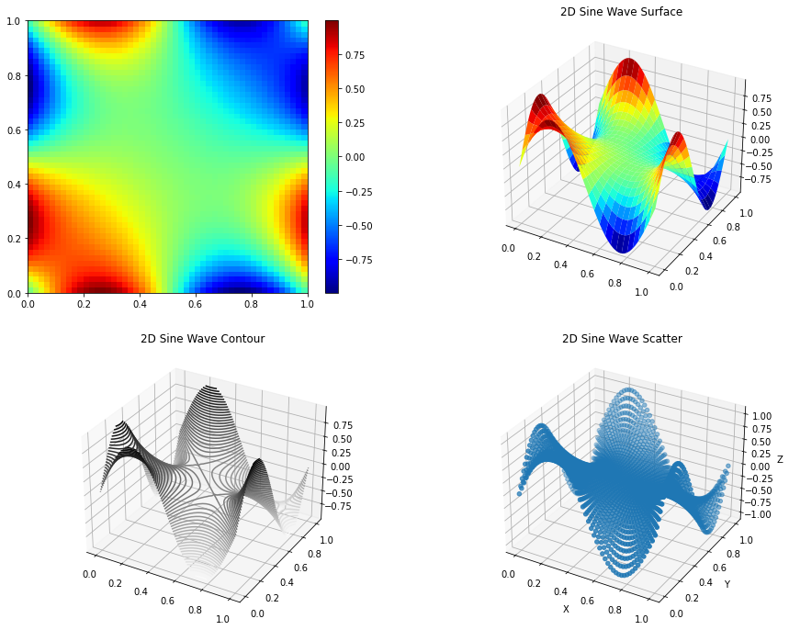

Figure : Heat Map and surface plot of the wave equation at 0.02 resolution and 20s

G) Other remarks (limits of the model, convergence problems, possible alternative approaches, anything you find relevant and important to mention):

In real life, the wave should eventually settle as the impact energy dissipates. However, this result loops, as body and external forces are not considered, so no energy is lost. This result might thus be more accurate for a wave machine which constantly transmits energy, or the waves made by a boat in neutral within a harbour. Our model correctly assesses the boundary conditions of the 1x1m square tank, which wouldn’t be realistic for a harbour model. The method used forgoes any convergence problems as dt is set to fulfil the stability conditions.

Alternatively, path B could have been used, solving the PDE in 1D with one time variable, then solving explicitly and implicitly, however this wouldn’t give as good an overview of the effects of this wave. Additionally, solving the 2D wave equation implicitly would have added unnecessary complications to the computing.

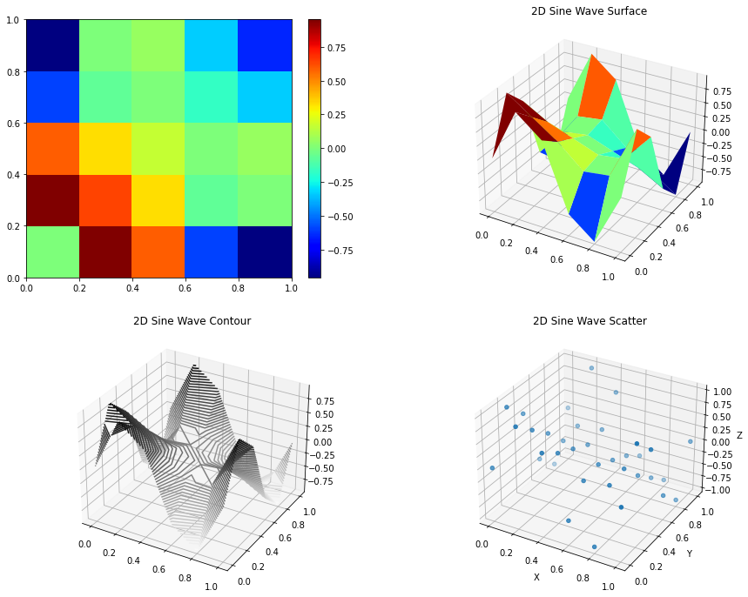

Figure : Heat Map and surface plot of the wave equation at 0.2 resolution and 10s

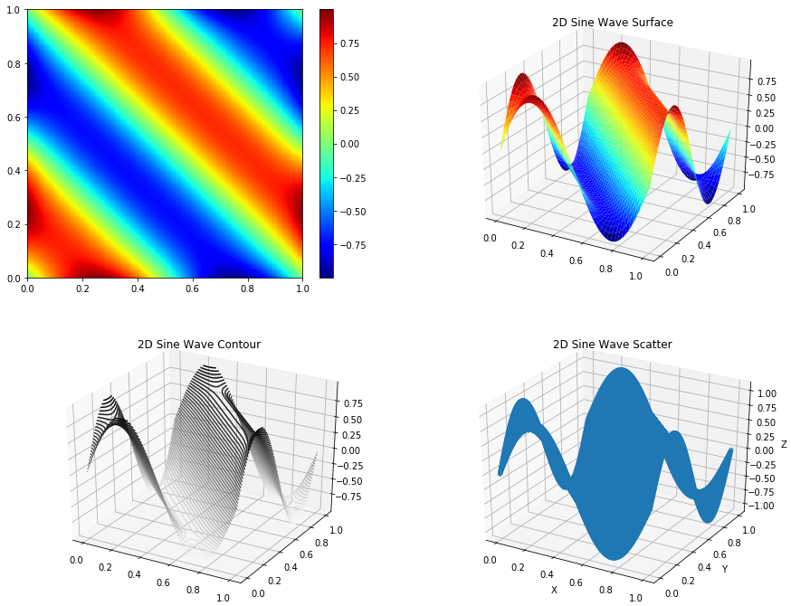

Figure : Heat Map and surface plot of the wave equation at 0004 resolution and 1s

The heat maps further show the importance of a small step size, as larger ones are indiscernible. Indeed, the GIF shown at the following link has a step size of 0.2, and the waveform is unclear.

https://imperiallondon-my.sharepoint.com/:i:/g/personal/tlb120_ic_ac_uk/Ef2rLnQ1JNVNtRAwZTMEpqIB_lfq7Vq9aj8l2JK3saLwfw?e=4%3agobg3U&at=9